Unit 22:

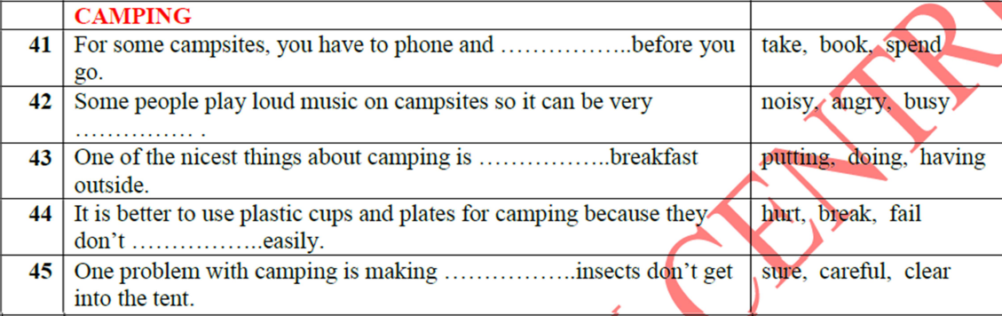

To book st:

Have breakfast / lunch/ dinner

Break

Make sure

Wait for / a long way / take a lift: 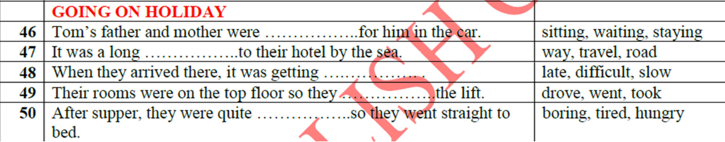

Supper – meal (tired)

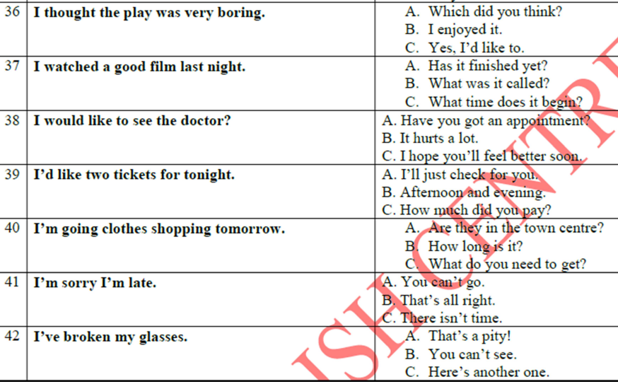

Get = buy

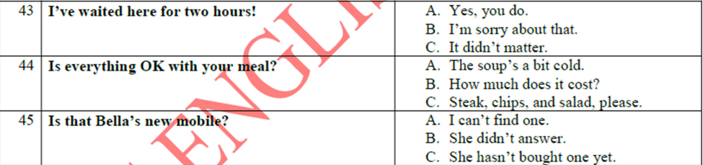

Reading part 3_1

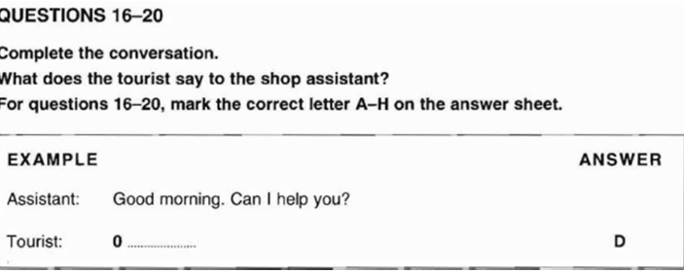

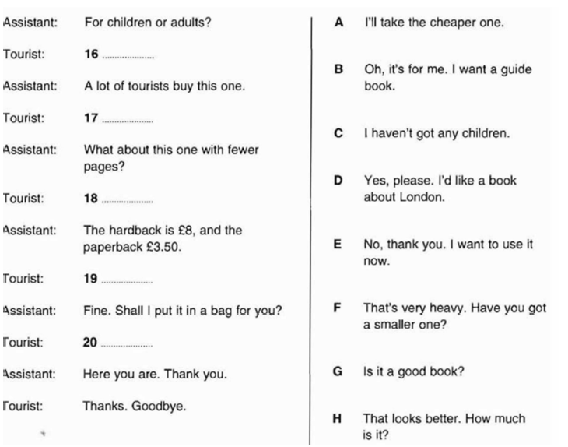

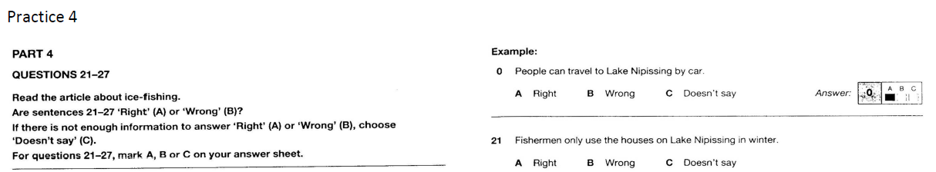

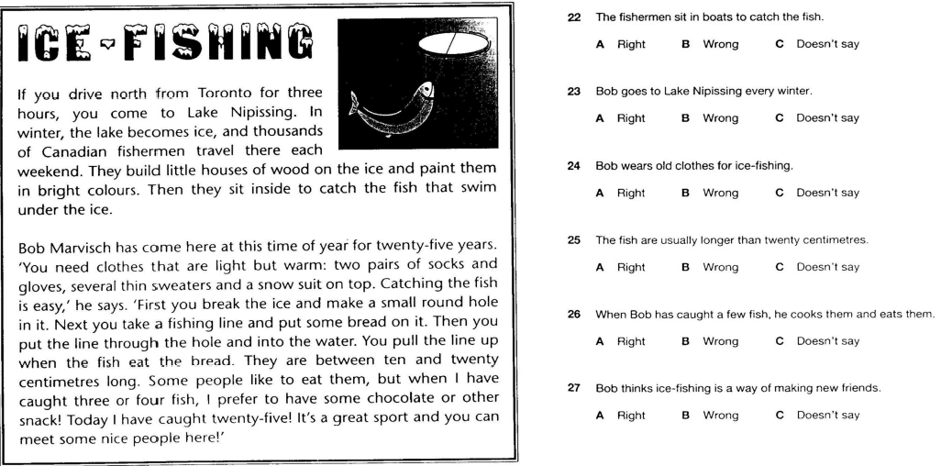

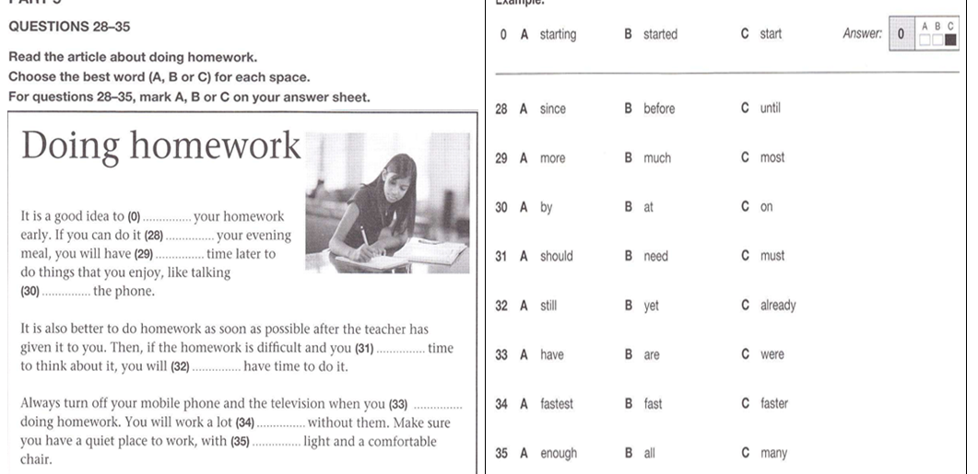

**Practice 12:**

1. **COME 41. OF/ABOUT 42. WHEN 43. WAS 44. LIKE 45. NEXT 46. LOT 47. HAVE**

**48. HOW 49. ARE 50. IT**



**Listening PART 4+5 TEST 5**

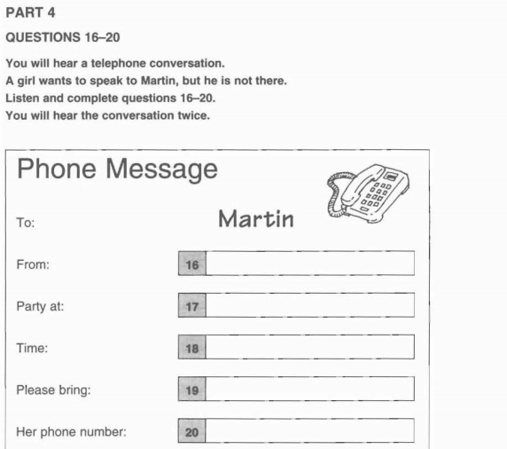

**16. Elaine 17. Grand hotel 18. 8.30 pm 19. A friend 20. 7245936**

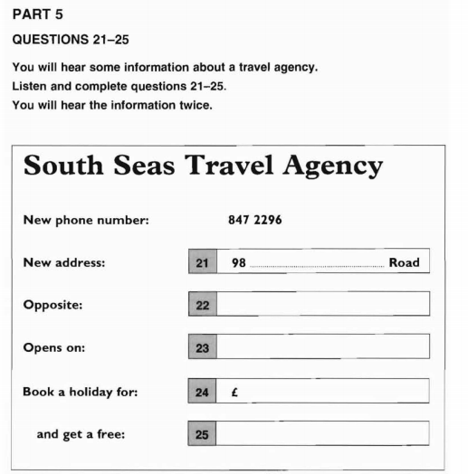21. Warnock 22. Bank 23. 21 May 24. £ 350 25. Travel bag

**SPEAKING PART 2:**

|  |  |
| --- | --- |
|  | 1. **What is the name of the language school?** 2. **Are there any English classes in the school?**   **Yes, there are.**   1. **How many hours are there in a course?**   **There are 15 hours every week.**   1. **How much is a course?**   **It is 180 pounds.**   1. **When does the course begin?**   **It begins on the 29th of April.**   1. **Where is the party?**  * **It is in Garden room Grand hotel**  1. **Whose party is it?**   **It is Peter’s party.**   1. **Why does he have this party?**  * **Because he’s passed his school exams.**  1. **When does the party finish?**   **It finishes at 11.30 pm**   1. **Can you dance at the party?**   **Yes, I can.** |

**Practice 13:**





